**Collections in Java**

**Collections in Java**

All the operations that you perform on a data such as searching, sorting, insertion, manipulation, deletion etc. can be performed by Java Collections.**Collections in java** is a framework that provides an architecture to store and manipulate the group of objects.

Java Collection simply means a single unit of objects. Java Collection framework provides many interfaces (Set, List, Queue, Deque etc.) and classes (ArrayList, Vector, LinkedList, PriorityQueue, HashSet, LinkedHashSet, TreeSet etc).

**What is Collection in java**

Collection represents a single unit of objects i.e. a group.

What is framework in java

* provides readymade architecture.
* represents set of classes and interface.
* is optional.

What is Collection framework

Collection framework represents a unified architecture for storing and manipulating group of objects. It has:

1. Interfaces and its implementations i.e. classes
2. Algorithm

*Hierarchy of Collection Framework*Let us see the hierarchy of collection framework.The **java.util** package contains all the classes and interfaces for Collection framework.  
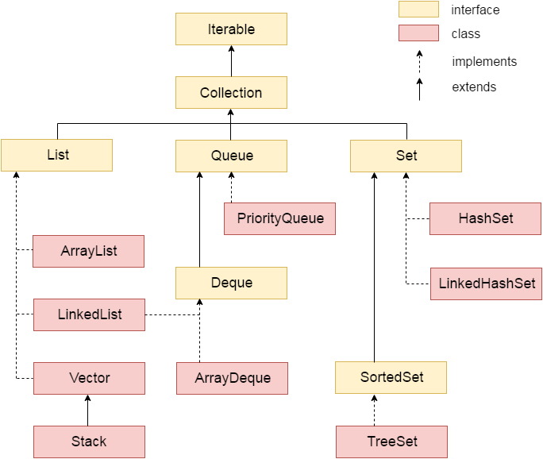

**Methods of Collection interface**

There are many methods declared in the Collection interface. They are as follows:

|  |  |  |
| --- | --- | --- |
| **No.** | **Method** | **Description** |
| 1 | public boolean add(Object element) | is used to insert an element in this collection. |
| 2 | public boolean addAll(Collection c) | is used to insert the specified collection elements in the invoking collection. |
| 3 | public boolean remove(Object element) | is used to delete an element from this collection. |
| 4 | public boolean removeAll(Collection c) | is used to delete all the elements of specified collection from the invoking collection. |
| 5 | public boolean retainAll(Collection c) | is used to delete all the elements of invoking collection except the specified collection. |
| 6 | public int size() | return the total number of elements in the collection. |
| 7 | public void clear() | removes the total no of element from the collection. |
| 8 | public boolean contains(Object element) | is used to search an element. |
| 9 | public boolean containsAll(Collection c) | is used to search the specified collection in this collection. |
| 10 | public Iterator iterator() | returns an iterator. |
| 11 | public Object[] toArray() | converts collection into array. |
| 12 | public boolean isEmpty() | checks if collection is empty. |
| 13 | public boolean equals(Object element) | matches two collection. |
| 14 | public int hashCode() | returns the hashcode number for collection. |

**Iterator interface**

|  |
| --- |
| Iterator interface provides the facility of iterating the elements in forward direction only. |

Methods of Iterator interface

There are only three methods in the Iterator interface. They are:

|  |  |  |
| --- | --- | --- |
| **No.** | **Method** | **Description** |
| 1 | public boolean hasNext() | It returns true if iterator has more elements. |
| 2 | public Object next() | It returns the element and moves the  cursor pointer to the next element. |
| 3 | public void remove() | It removes the last elements returned by the iterator.  It is rarely used. |